**CS3431-A22 Assignment 4 Solutions**

**Part 1a – Organ Transplants**

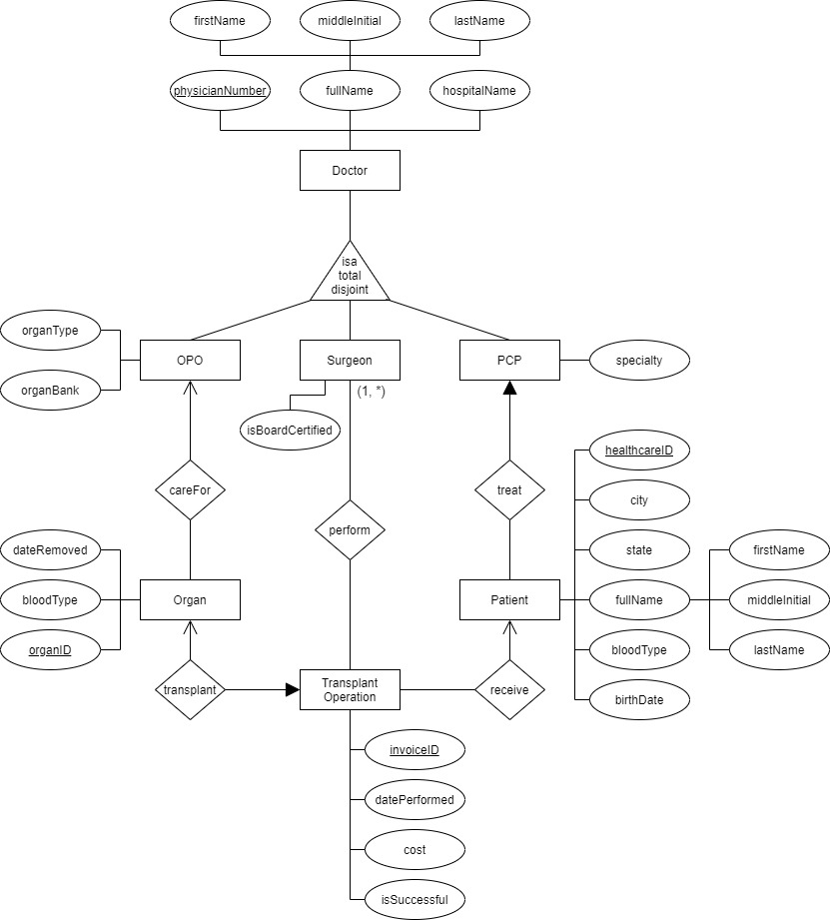

**Part 1b**

Since the uniqueness of the patient is dependent on the PCP doctor, then the Patient is a weak entity with a weak relationship with PCP. HealthcareID is then a discriminant. Note that the primary key of PCP is physicianNumber since it has an ISA relationship with Doctor. Therefore, the ERD mapping to the schema for Patient is

Patient (healthcareID, physicianNumber, city, state, firstName, middleInitial, lastName, bloodType, birthDate)  
Everything else is the same as in Part 1a.

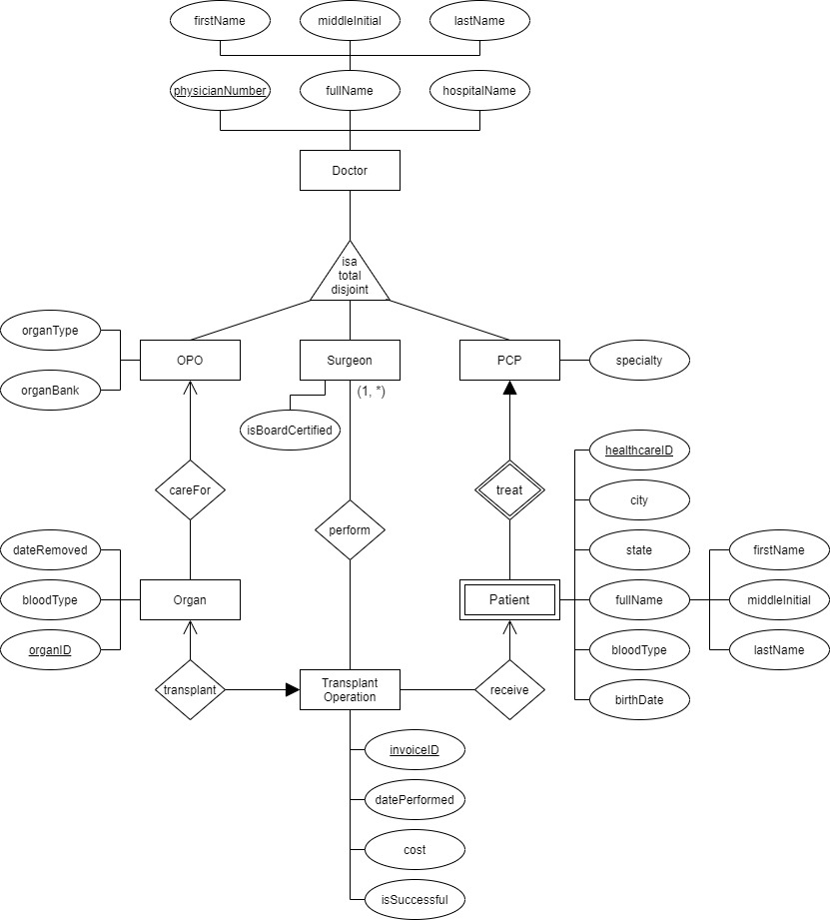

**Part 2**

1. Assumption: A building can have more than one department in it.
2. Assumption: A mentor can have many mentees
3. Assumption: A mentee can have many mentors
4. Since cardinalities are between entities and not with multi-valued attributes, Phone has to be a weak 1-to-many entity with a relationship with Employee.

